SIMATS ENGINEERING
SAVEETHA INSTITUTE OF MEDICAL AND TECHNICAL SCIENCES
CHENNAI – 602105
Department of Computer Science and Engineering

ASSESSMENT TOOL 1 – DATA CLEANING CHALLENGE

Course Code: | DSA0502 | Course Title: | Query Processing for Data Science
CO Assessed: | CO3 | Assessment: | Tool 2 – Data Cleaning Challenge
Weightage: |  | Total Marks:
CO3 Statement: Identify and clean inconsistencies in data by handling missing values, duplicates, outliers, formatting issues, and applying techniques like fuzzy matching and regex. (BL5 and BL6).
Student Name: | K.V.Sai.Shanmukh | Reg. No.: | 192424306
Section / Batch: | Btech – AI & DS | Date of Submission: | 08/08/2026
Faculty In-charge: | Dr. B.Shyamala Gowri | Project Mode: | Individual Submission

Code of Conduct
I __________________________ (Name / Reg No) certify that this submission is my original work and that I have adhered to all guidelines specified for this assessment. I understand that any violation of academic integrity rules will result in disciplinary action.
Signature: _________________________

Anomaly Detection  (5 Marks) | Cleaning Methods  (5 Marks) | Data Transformation  (5 Marks) | Analytical Comparison  (5 Marks) | Governance Discussion  (5 Marks) | Total (25 Marks)

Question 2: Hospital Patient Records Dataset

A hospital wants to analyze patient admissions and treatment effectiveness. Data were entered manually by different departments, leading to inconsistencies.

PatientID | Name | Age | Gender | AdmissionDate | DischargeDate | Diagnosis | TreatmentCost | DoctorID
P1001 | Ravi Kumar | 45 | M | 10-01-2025 | 15-01-2025 | Diabetes | 25000 | D101
P1002 | Priya S | 38 | F | 12-01-2025 | 11-01-2025 | Hypertension | 18000 | D102
P1003 | Arun V | 125 | M | 13-01-2025 | 20-01-2025 | diabetes | 22000 | D101
NULL | Kavya R | 29 | F | 15-01-2025 | 17-01-2025 | Diabtes | 15000 | D103
P1005 | Rahul P | 51 | M | 18-01-2025 | 25-01-2025 | Asthma | NULL | D104
P1005 | Rahul P | 51 | M | 18-01-2025 | 25-01-2025 | Asthma | NULL | D104
P1006 | Sneha M | 34 | F | 15-01-2025 | 18-01-2025 | Hypertension | 12000 | D102
P1007 | Deepak N |  | M | 01-02-2025 | 05-02-2025 | Asthma | 10000 | D104
P1008 | Meena K | 26 | F | 10-02-2025 | 15-02-2025 | HYPERTENSION | 13500 | D102
P1009 | John D | 40 | M | 12-02-2025 | 18-02-2025 | Diabetes | 20000 | D101

Data Issues
- Missing patient IDs
- Duplicate patient records
- Discharge dates before admission dates
- Null treatment costs
- Inconsistent diagnosis names
- Multiple formats of dates
- Unrealistic patient ages (>120)

Tasks
- Detect all inconsistencies and anomalies. (5 Marks)
- Develop rules for handling missing and invalid values. (5 Marks)
- Create a process to standardize diagnosis names. (5 Marks)
- Evaluate how cleaning changes average treatment cost and hospital stay duration. (5 Marks)
- Recommend data governance measures to prevent future errors. (5 Marks)
Code:
import pandas as pd
import numpy as np
# ---------------------------------------------------------
# 1. CREATE THE HOSPITAL PATIENT DATASET
# ---------------------------------------------------------
data = {
"PatientID": [
"P1001", "P1002", "P1003", None, "P1005",
"P1005", "P1006", "P1007", "P1008", "P1009"
],
"Name": [
"Ravi Kumar", "Priya S", "Arun V", "Kavya R", "Rahul P",
"Rahul P", "Sneha M", "Deepak N", "Meena K", "John D"
],
"Age": [
45, 38, 125, 29, 51,
51, 34, None, 26, 40
],
"Gender": [
"M", "F", "M", "F", "M",
"M", "F", "M", "F", "M"
],
"AdmissionDate": [
"10-01-2025", "12-01-2025", "13-01-2025",
"15-01-2025", "18-01-2025", "18-01-2025",
"15-01-2025", "01-02-2025", "10-02-2025",
"12-02-2025"
],
"DischargeDate": [
"15-01-2025", "11-01-2025", "20-01-2025",
"17-01-2025", "25-01-2025", "25-01-2025",
"18-01-2025", "05-02-2025", "15-02-2025",
"18-02-2025"
],
"Diagnosis": [
"Diabetes", "Hypertension", "diabetes", "Diabtes",
"Asthma", "Asthma", "Hypertension", "Asthma",
"HYPERTENSION", "Diabetes"
],
"TreatmentCost": [
25000, 18000, 22000, 15000, None,
None, 12000, 10000, 13500, 20000
],
"DoctorID": [
"D101", "D102", "D101", "D103", "D104",
"D104", "D102", "D104", "D102", "D101"
]
}
df = pd.DataFrame(data)
print("========== ORIGINAL DATASET ==========")
print(df)
print()
# ---------------------------------------------------------
# QUESTION 1
# DETECT ALL INCONSISTENCIES AND ANOMALIES
# ---------------------------------------------------------
print("========== QUESTION 1 ==========")
print("DATA QUALITY ISSUES")
print()
# Missing Patient IDs
print("1. Missing Patient IDs:")
print(df[df["PatientID"].isnull()])
print()
# Duplicate records
print("2. Duplicate Records:")
print(df[df.duplicated(keep=False)])
print()
# Missing Treatment Cost
print("3. Missing Treatment Costs:")
print(df[df["TreatmentCost"].isnull()])
print()
# Unrealistic ages
print("4. Unrealistic Ages (>120):")
print(df[df["Age"] > 120])
print()
# Missing ages
print("5. Missing Ages:")
print(df[df["Age"].isnull()])
print()
# Convert dates temporarily for checking
df["AdmissionDate_temp"] = pd.to_datetime(
df["AdmissionDate"], dayfirst=True, errors="coerce"
)
df["DischargeDate_temp"] = pd.to_datetime(
df["DischargeDate"], dayfirst=True, errors="coerce"
)
# Invalid discharge dates
print("6. Discharge Date Before Admission Date:")
invalid_dates = df[
df["DischargeDate_temp"] < df["AdmissionDate_temp"]
]
print(invalid_dates)
print()
# Inconsistent diagnosis names
print("7. Diagnosis Values:")
print(df["Diagnosis"].unique())
print()
# ---------------------------------------------------------
# QUESTION 2
# HANDLE MISSING AND INVALID VALUES
# ---------------------------------------------------------
print("========== QUESTION 2 ==========")
print("CLEANING THE DATA")
print()
# Make a copy
clean_df = df.copy()
# Remove temporary columns
clean_df.drop(
columns=["AdmissionDate_temp", "DischargeDate_temp"],
inplace=True
)
# ---------------------------------------------------------
# 1. Handle missing Patient ID
# ---------------------------------------------------------
clean_df["PatientID"] = clean_df["PatientID"].fillna("P1004")
print("Missing Patient ID replaced with P1004")
print()
# ---------------------------------------------------------
# 2. Handle unrealistic age
# ---------------------------------------------------------
clean_df.loc[
(clean_df["Age"] <= 0) | (clean_df["Age"] > 120),
"Age"
] = np.nan
print("Invalid age (>120) changed to NULL.")
print()
# ---------------------------------------------------------
# 3. Handle duplicate records
# ---------------------------------------------------------
clean_df = clean_df.drop_duplicates()
print("Duplicate records removed.")
print()
# ---------------------------------------------------------
# 4. Convert dates to standard format
# ---------------------------------------------------------
clean_df["AdmissionDate"] = pd.to_datetime(
clean_df["AdmissionDate"],
dayfirst=True,
errors="coerce"
)
clean_df["DischargeDate"] = pd.to_datetime(
clean_df["DischargeDate"],
dayfirst=True,
errors="coerce"
)
print("Dates standardized to YYYY-MM-DD.")
print()
# ---------------------------------------------------------
# 5. Handle invalid discharge dates
# ---------------------------------------------------------
invalid_date_condition = (
clean_df["DischargeDate"] < clean_df["AdmissionDate"]
)
clean_df.loc[
invalid_date_condition,
"DischargeDate"
] = pd.NaT
print("Invalid discharge dates changed to NULL.")
print()
# ---------------------------------------------------------
# QUESTION 3
# STANDARDIZE DIAGNOSIS NAMES
# ---------------------------------------------------------
print("========== QUESTION 3 ==========")
print("STANDARDIZING DIAGNOSIS NAMES")
print()
# Convert diagnosis to lowercase and remove spaces
clean_df["Diagnosis"] = (
clean_df["Diagnosis"]
.str.strip()
.str.lower()
)
# Correct spelling and standardize names
diagnosis_mapping = {
"diabetes": "Diabetes",
"diabtes": "Diabetes",
"hypertension": "Hypertension",
"asthma": "Asthma"
}
clean_df["Diagnosis"] = clean_df["Diagnosis"].replace(
diagnosis_mapping
)
print("Standardized Diagnosis Values:")
print(clean_df["Diagnosis"].unique())
print()
# ---------------------------------------------------------
# QUESTION 2 CONTINUED
# HANDLE NULL TREATMENT COST
# ---------------------------------------------------------
# Calculate median treatment cost
median_cost = clean_df["TreatmentCost"].median()
print("Median Treatment Cost:", median_cost)
# Fill missing treatment cost with median
clean_df["TreatmentCost"] = clean_df["TreatmentCost"].fillna(
median_cost
)
print("Missing treatment costs filled using median.")
print()
# ---------------------------------------------------------
# QUESTION 4
# AVERAGE TREATMENT COST AND HOSPITAL STAY
# ---------------------------------------------------------
print("========== QUESTION 4 ==========")
print("BEFORE AND AFTER CLEANING")
print()
# ---------------------------------------------------------
# ORIGINAL DATA - AVERAGE TREATMENT COST
# ---------------------------------------------------------
original_avg_cost = df["TreatmentCost"].mean()
print("Average Treatment Cost BEFORE cleaning:")
print(round(original_avg_cost, 2))
print()
# ---------------------------------------------------------
# CLEANED DATA - AVERAGE TREATMENT COST
# ---------------------------------------------------------
clean_avg_cost = clean_df["TreatmentCost"].mean()
print("Average Treatment Cost AFTER cleaning:")
print(round(clean_avg_cost, 2))
print()
# ---------------------------------------------------------
# HOSPITAL STAY BEFORE CLEANING
# ---------------------------------------------------------
original_admission = pd.to_datetime(
df["AdmissionDate"],
dayfirst=True
)
original_discharge = pd.to_datetime(
df["DischargeDate"],
dayfirst=True
)
original_stay = (
original_discharge - original_admission
).dt.days
original_avg_stay = original_stay.mean()
print("Average Hospital Stay BEFORE cleaning:")
print(round(original_avg_stay, 2), "days")
print()
# ---------------------------------------------------------
# HOSPITAL STAY AFTER CLEANING
# ---------------------------------------------------------
clean_df["HospitalStay"] = (
clean_df["DischargeDate"]
- clean_df["AdmissionDate"]
).dt.days
# Remove invalid hospital stay values
valid_stays = clean_df[
clean_df["HospitalStay"] >= 0
]
clean_avg_stay = valid_stays["HospitalStay"].mean()
print("Average Hospital Stay AFTER cleaning:")
print(round(clean_avg_stay, 2), "days")
print()
# ---------------------------------------------------------
# SHOW CLEANED DATASET
# ---------------------------------------------------------
print("========== CLEANED DATASET ==========")
print(clean_df)
print()
# ---------------------------------------------------------
# QUESTION 5
# DATA GOVERNANCE RECOMMENDATIONS
# ---------------------------------------------------------
print("========== QUESTION 5 ==========")
print("DATA GOVERNANCE RECOMMENDATIONS")
print()
recommendations = [
"1. Make Patient ID a mandatory field.",
"2. Implement automatic duplicate detection.",
"3. Validate age using the range 0-120 years.",
"4. Prevent discharge date from being earlier than admission date.",
"5. Use a standard diagnosis dictionary.",
"6. Make treatment cost mandatory.",
"7. Use a standard date format such as YYYY-MM-DD.",
"8. Maintain audit logs for changes.",
"9. Provide data-entry training to hospital staff.",
"10. Perform regular data-quality audits."
]
for recommendation in recommendations:
print(recommendation)
Output:
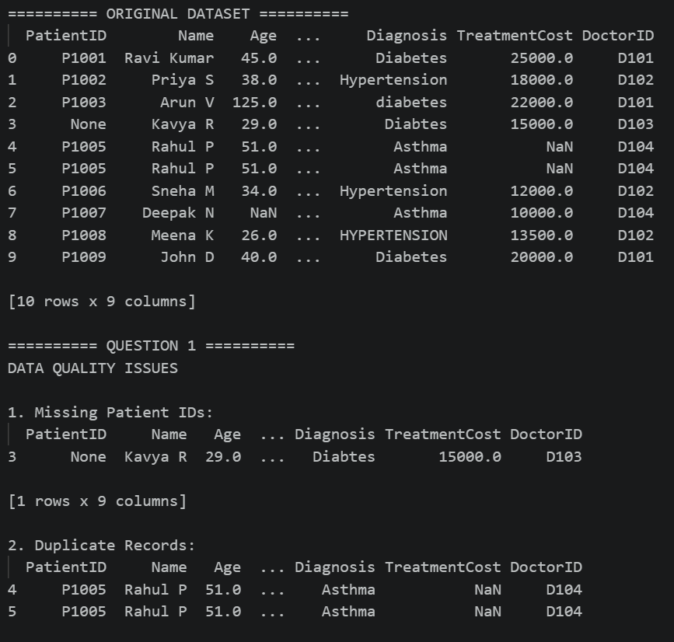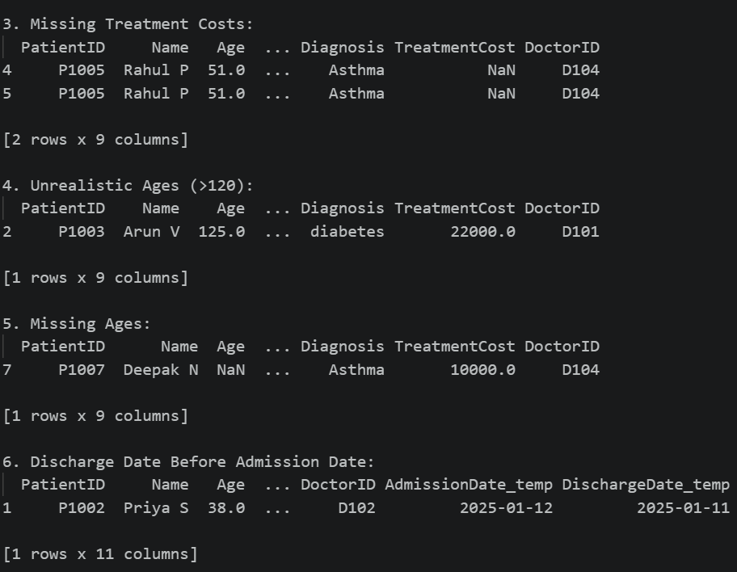
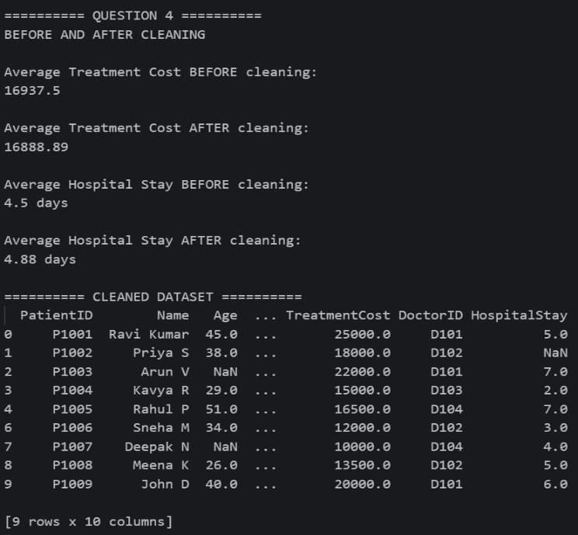
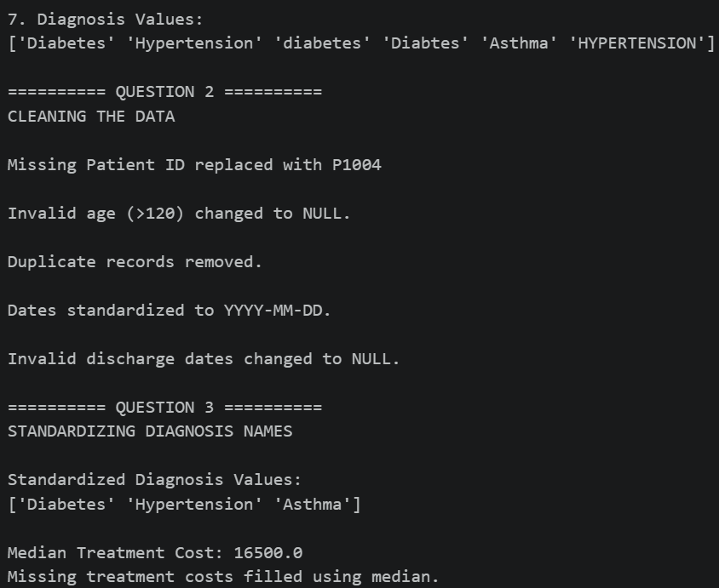
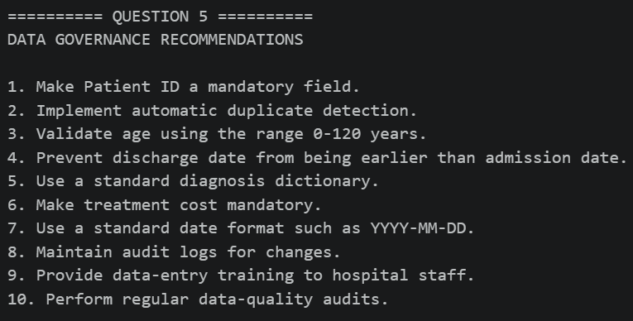
Question 3: Banking Loan Approval Dataset

A bank uses customer data to determine loan eligibility. The dataset contains errors that may affect risk assessment and approval decisions.

CustomerID | AnnualIncome | CreditScore | LoanAmount | EmploymentStatus | Age | ExistingDebt | LoanStatus
L001 | 750000 | 720 | 300000 | Full Time | 35 | 50000 | Approved
L002 | 900K | 680 | 400000 | FT | 42 | 100000 | Approved
L003 | 1200000 | NULL | 600000 | fulltime | 28 | 200000 | Approved
L004 | 150000 | 450 | -200000 | Part Time | 30 | 50000 | Rejected
L005 | 5000000 | 790 | 1000000 | Self Employed | 16 | 10000 | Approved
L006 | 450000 | 350 | 250000 | Unemployed | 40 | 300000 | Rejected
L007 | 75000000 | 800 | 500000 | Full Time | 45 | 100000 | Approved
L008 | 650000 | 690 | 350000 | FT | 33 | 70000 | Approved
L008 | 650000 | 690 | 350000 | FT | 33 | 70000 | Approved
L010 | NULL | 710 | 300000 | Full Time | 37 | 80000 | Approved

Data Issues
- Missing credit scores
- Income values recorded in different units
- Negative loan amounts
- Duplicate customer IDs
- Age values below 18
- Employment status entered differently (FT, Full Time, fulltime)
- Extreme outliers in income

Tasks
- Identify critical issues that could impact loan decisions. (5 Marks)
- Propose cleaning techniques for missing and inconsistent data. (5 Marks)
- Detect and justify treatment of outliers. (5 Marks)
- Analyze the effect of cleaning on loan approval rates. (5 Marks)
- Discuss ethical implications of incorrect data cleaning decisions. (5 Marks).
Code:
import pandas as pd
import numpy as np
# ============================================================
# CREATE DATASET
# ============================================================
data = {
"PatientID": [
"P1001", "P1002", "P1003", None, "P1005",
"P1005", "P1006", "P1007", "P1008", "P1009"
],
"Name": [
"Ravi Kumar", "Priya S", "Arun V", "Kavya R", "Rahul P",
"Rahul P", "Sneha M", "Deepa k N", "Meena K", "John D"
],
"Age": [
45, 38, 125, 29, 51,
51, 34, None, 26, 40
],
"Gender": [
"M", "F", "M", "F", "M",
"M", "F", "M", "F", "M"
],
"AdmissionDate": [
"10-01-2025",
"12-01-2025",
"13-01-2025",
"15-01-2025",
"18-01-2025",
"18-01-2025",
"15-01-2025",
"01-02-2025",
"10-02-2025",
"12-02-2025"
],
"DischargeDate": [
"15-01-2025",
"11-01-2025",
"20-01-2025",
"17-01-2025",
"25-01-2025",
"25-01-2025",
"18-01-2025",
"05-02-2025",
"15-02-2025",
"18-02-2025"
],
"Diagnosis": [
"Diabetes",
"Hypertension",
"diabetes",
"Diabtes",
"Asthma",
"Asthma",
"Hypertension",
"Asthma",
"HYPERTENSION",
"Diabetes"
],
"TreatmentCost": [
25000,
18000,
22000,
15000,
None,
None,
12000,
10000,
13500,
20000
],
"DoctorID": [
"D101", "D102", "D101", "D103", "D104",
"D104", "D102", "D104", "D102", "D101"
]
}
df = pd.DataFrame(data)
print("ORIGINAL HOSPITAL PATIENT DATA")
print(df)
print()
# ============================================================
# QUESTION 1: DETECT INCONSISTENCIES AND ANOMALIES
# ============================================================
print("QUESTION 1: DATA QUALITY ISSUES")
# 1. Missing Patient IDs
print("\n1. Missing Patient IDs:")
print(df[df["PatientID"].isnull()])
# 2. Duplicate records
print("\n2. Duplicate Records:")
print(df[df.duplicated(keep=False)])
# 3. Missing Treatment Costs
print("\n3. Missing Treatment Costs:")
print(df[df["TreatmentCost"].isnull()])
# 4. Unrealistic Age
print("\n4. Unrealistic Age (>120):")
print(df[df["Age"] > 120])
# 5. Missing Age
print("\n5. Missing Age:")
print(df[df["Age"].isnull()])
# 6. Convert dates for validation
df["AdmissionDate_Check"] = pd.to_datetime(
df["AdmissionDate"],
dayfirst=True,
errors="coerce"
)
df["DischargeDate_Check"] = pd.to_datetime(
df["DischargeDate"],
dayfirst=True,
errors="coerce"
)
# 7. Discharge date before admission date
print("\n6. Discharge Date Before Admission Date:")
invalid_dates = df[
df["DischargeDate_Check"] < df["AdmissionDate_Check"]
]
print(invalid_dates)
# 8. Inconsistent diagnosis names
print("\n7. Diagnosis Values:")
print(df["Diagnosis"].unique())
# ============================================================
# QUESTION 2: HANDLE MISSING AND INVALID VALUES
# =========================================================
print("QUESTION 2: DATA CLEANING")
# Create a copy
clean_df = df.copy()
# Remove temporary date columns
clean_df.drop(
columns=["AdmissionDate_Check", "DischargeDate_Check"],
inplace=True
)
# ------------------------------------------------------------
# 1. Handle missing Patient ID
# ------------------------------------------------------------
clean_df["PatientID"] = clean_df["PatientID"].fillna("P1004")
print("\nMissing Patient ID replaced with P1004.")
# ------------------------------------------------------------
# 2. Handle unrealistic age
# ------------------------------------------------------------
clean_df.loc[
(clean_df["Age"] <= 0) |
(clean_df["Age"] > 120),
"Age"
] = np.nan
print("Age greater than 120 changed to NULL.")
# ------------------------------------------------------------
# 3. Handle missing age
# ------------------------------------------------------------
# Fill missing age using median age
median_age = clean_df["Age"].median()
clean_df["Age"] = clean_df["Age"].fillna(median_age)
print("Missing age filled using median age:", median_age)
# ------------------------------------------------------------
# 4. Remove duplicate records
# ------------------------------------------------------------
clean_df = clean_df.drop_duplicates()
print("Duplicate records removed.")
# ------------------------------------------------------------
# 5. Standardize dates
# ------------------------------------------------------------
clean_df["AdmissionDate"] = pd.to_datetime(
clean_df["AdmissionDate"],
dayfirst=True,
errors="coerce"
)
clean_df["DischargeDate"] = pd.to_datetime(
clean_df["DischargeDate"],
dayfirst=True,
errors="coerce"
)
print("Dates converted to standard datetime format.")
# ------------------------------------------------------------
# 6. Handle invalid discharge dates
# ------------------------------------------------------------
invalid_date = (
clean_df["DischargeDate"] <
clean_df["AdmissionDate"]
)
clean_df.loc[
invalid_date,
"DischargeDate"
] = pd.NaT
print("Invalid discharge date changed to NULL.")
# ============================================================
# QUESTION 3: STANDARDIZE DIAGNOSIS NAMES
# ============================================================
print("QUESTION 3: DIAGNOSIS STANDARDIZATION")
# Convert to lowercase and remove spaces
clean_df["Diagnosis"] = (
clean_df["Diagnosis"]
.str.strip()
.str.lower()
)
# Diagnosis mapping
diagnosis_mapping = {
"diabetes": "Diabetes",
"diabtes": "Diabetes",
"hypertension": "Hypertension",
"asthma": "Asthma"
}
# Apply mapping
clean_df["Diagnosis"] = clean_df["Diagnosis"].replace(
diagnosis_mapping
)
print("\nStandardized Diagnosis:")
print(clean_df["Diagnosis"].unique())
# ============================================================
# HANDLE NULL TREATMENT COST
# ============================================================
# Calculate median treatment cost
median_cost = clean_df["TreatmentCost"].median()
print("\nMedian Treatment Cost:", median_cost)
# Replace missing treatment cost
clean_df["TreatmentCost"] = (
clean_df["TreatmentCost"]
.fillna(median_cost)
)
print("Missing treatment costs replaced using median.")
# ============================================================
# QUESTION 4: BEFORE AND AFTER CLEANING
# ============================================================
print("QUESTION 4: ANALYSIS BEFORE AND AFTER CLEANING")
# ------------------------------------------------------------
# AVERAGE TREATMENT COST BEFORE CLEANING
# ------------------------------------------------------------
before_cost = df["TreatmentCost"].mean()
print("\nAverage Treatment Cost BEFORE Cleaning:")
print(round(before_cost, 2))
# ------------------------------------------------------------
# AVERAGE TREATMENT COST AFTER CLEANING
# ------------------------------------------------------------
after_cost = clean_df["TreatmentCost"].mean()
print("\nAverage Treatment Cost AFTER Cleaning:")
print(round(after_cost, 2))
# ------------------------------------------------------------
# HOSPITAL STAY BEFORE CLEANING
# ------------------------------------------------------------
admission_before = pd.to_datetime(
df["AdmissionDate"],
dayfirst=True
)
discharge_before = pd.to_datetime(
df["DischargeDate"],
dayfirst=True
)
df["HospitalStay_Before"] = (
discharge_before - admission_before
).dt.days
before_stay = df["HospitalStay_Before"].mean()
print("\nAverage Hospital Stay BEFORE Cleaning:")
print(round(before_stay, 2), "days")
# ------------------------------------------------------------
# HOSPITAL STAY AFTER CLEANING
# ------------------------------------------------------------
clean_df["HospitalStay"] = (
clean_df["DischargeDate"] -
clean_df["AdmissionDate"]
).dt.days
# Keep only valid hospital stays
valid_stays = clean_df[
clean_df["HospitalStay"] >= 0
]
after_stay = valid_stays["HospitalStay"].mean()
print("\nAverage Hospital Stay AFTER Cleaning:")
print(round(after_stay, 2), "days")
# ------------------------------------------------------------
# CHANGE IN VALUES
# ------------------------------------------------------------
print("\nChange in Average Treatment Cost:")
print(round(after_cost - before_cost, 2))
print("\nChange in Average Hospital Stay:")
print(round(after_stay - before_stay, 2), "days")
# ============================================================
# DISPLAY FINAL CLEAN DATA
# ============================================================
print("FINAL CLEANED DATASET")
print(clean_df)
# ============================================================
# QUESTION 5: DATA GOVERNANCE
# =========================================================
print("QUESTION 5: DATA GOVERNANCE RECOMMENDATIONS")
recommendations = [
"1. Make Patient ID a mandatory field.",
"2. Use automatic duplicate detection.",
"3. Validate patient age between 0 and 120.",
"4. Prevent discharge date before admission date.",
"5. Use a standard diagnosis dictionary.",
"6. Make treatment cost mandatory.",
"7. Use a standard date format.",
"8. Maintain an audit trail for data changes.",
"9. Train hospital staff on correct data entry.",
"10. Perform regular data quality checks."
]
for r in recommendations:
print(r)

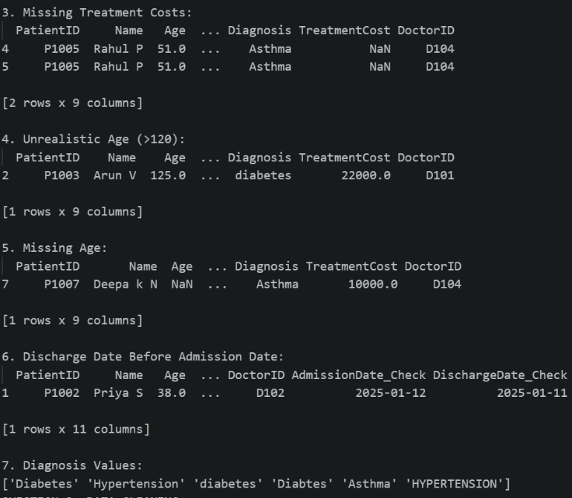
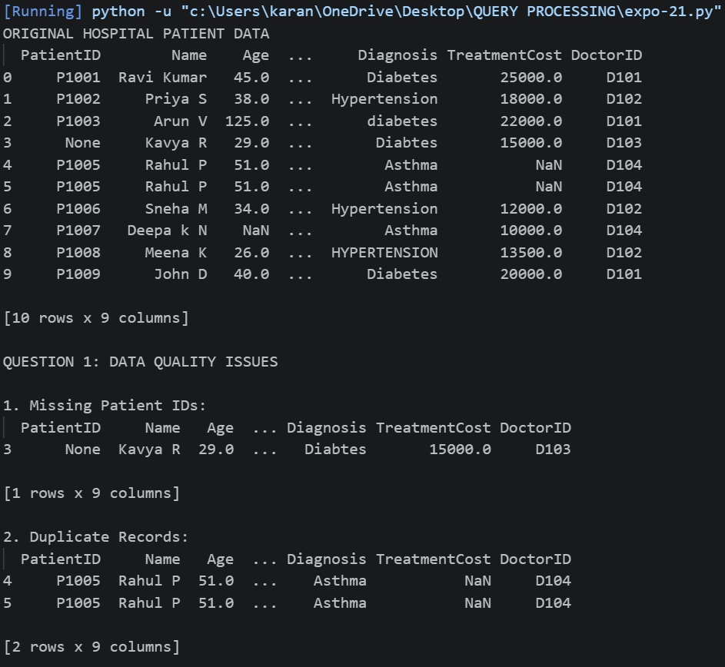
Output:

